Allspice-Rubbed Pork Tenderloin with Cinnamon-Sautéed Apples

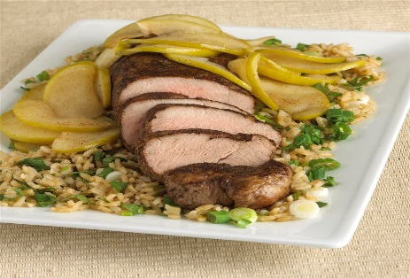
Here is a Simple Cooking with Heart pork dinner with some amazing sides that sound and taste so good, you won't believe that they're good for you too!

Ingredients

4 Servings
For the Pork Tenderloin:
- 1 lb pork tenderloin (all visible fat discarded)
- 1 tsp ground allspice
- 2 tsp extra-virgin olive oil, canola oil, vegetable or corn oil
- 1/4 tsp black pepper
- 4 apples, (Granny Smith or any apples you like) cored, washed, thinly sliced
- 1/2 tsp ground cinnamon

Directions
For the Pork Tenderloin:
- 1 Preheat oven to 400 degrees F. Coat tenderloin with allspice and pepper.
- 2 Warm oil over medium-high heat in large pan. Add tenderloin and brown each side of tenderloin for about 1 minute each (about 4 minutes total).
- 3 Transfer pork to a baking dish, and cook in oven until pork has 145° F internal temperature, about 25 minutes.
- 4 Meanwhile, in the original pan, add apples and cinnamon. Cook over medium-high heat stirring constantly until apples are soft, about 4 to 5 minutes. Take off heat.
- 5 Let pork rest for a few minutes. Slice into pieces and serve with apples on top.

Recipe copyright © 2016 American Heart Association. This recipe is brought to you by the American Heart Association's Simple Cooking with Heart ® Program. For more simple, quick and affordable recipes, visit heart.org/simplecooking.

